**2020安徽警官职业学院英语口语技能大赛（非专业组）**

**备赛试题**

**Task 1**

Here is a chart of a survey. Be prepared to discuss this chart and your view on college students’ preference in seeking a job after graduation.

**200 college students’ (100 boys and 100 girls) responses to the question**

**“What do you want to do after graduation?”**

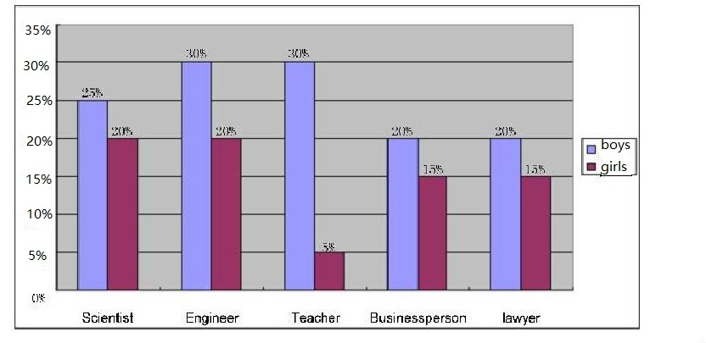

**Task 2**

**You are required to talk about the pie chart, describing and comparing what you have seen.**

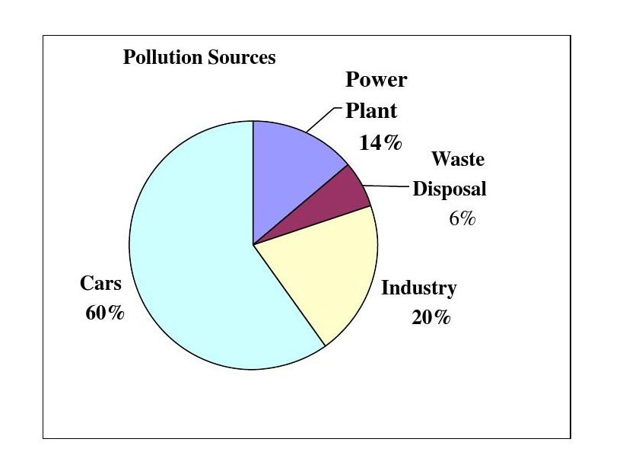

**Task 3**

**Here is a chart about college students’ on-line behaviors. You are required to talk about the figure, describing and comparing what you have seen.**

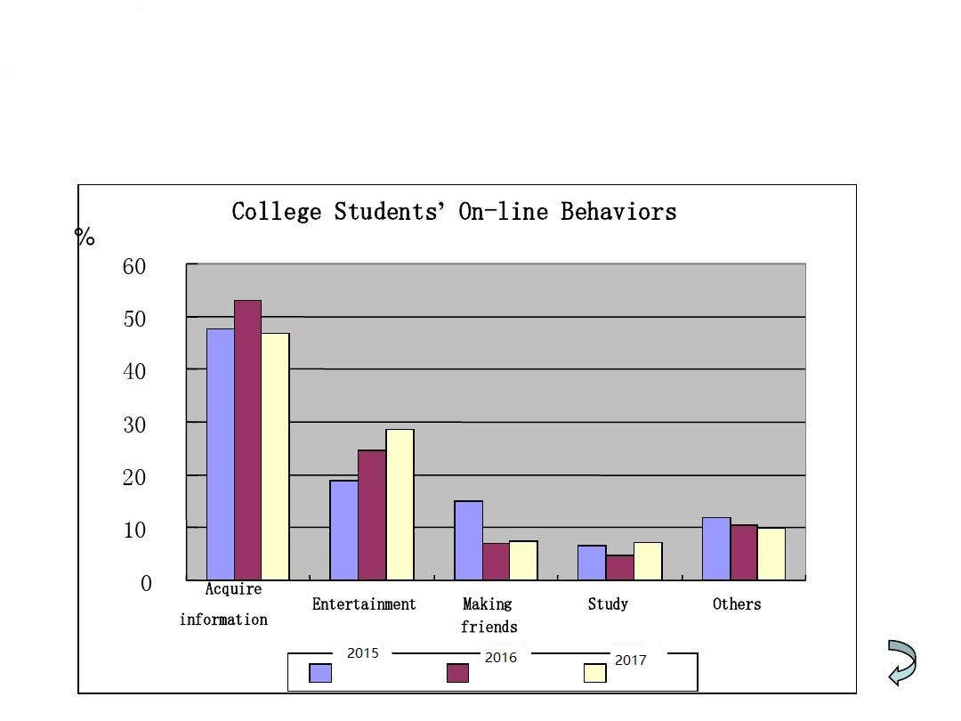

**Task 4**

**You are required to talk about the chart, describing and comparing what you have seen.**

**Waste made by companies from 2000 to 2015**

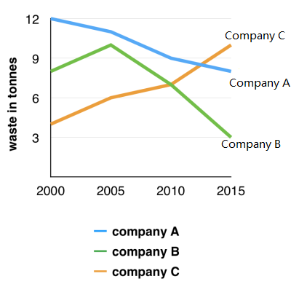

**Task 5**

**You are required to talk about the chart, describing and comparing what you have seen.**

